**Chapter 1: Moving worms**

1. Adjusting your dissecting microscope to parfocality.

Spread the ocular tubes until they are adjusted to your interpupil distance. In other words, you should be able to see through both eyepieces simultaneously to see a three-dimensional image.

Rotate your eye pieces until the tic marks are aligned at 0. Focus on a plate of worms at the lowest magnification. Zoom in to the highest magnification and refocus. Zoom out to the lowest magnification. Close one eye and rotate the eyepiece until it is in focus for your first eye. Close your other eye and rotate the eyepiece until it is in focus for your second eye. Now the sample should be in focus throughout the entire spectrum of magnifications.

NOTE: If your microscope has "high eyepoint" eyepieces you cannot rest your eye sockets on the eyepieces. This allows you to wear glasses while you use the microscope. If you are seeing a double image, it is probably because you are too close to the eyepieces.

2. Making a worm pick.

Cut a one-inch segment from the spool of platinum wire. Insert a little less than a quarter inch of the wire fragment into a short-nosed glass pipet. Hold the pipet tip over the flame of an alcohol burner and melt the glass around the wire (Fig. 1). Hold the wire horizontal with pliers or tweezers.



Figure 1. Attaching the platinum wire to a glass pipet.

Next, you need to flatten the tip of the wire into a disc. Grab about a millimeter of the tip of the wire with a pair of **jeweler’s** pliers. (Do not use 'needle nose pliers' which have teeth). Squeeze with all your might. If you haven't much might, place the nose of the pliers on the bench and tap the tip of the pliers with a heavy metal object like the handle of a pair of scissors or hammer. This will flatten the wire into a spoon shape at the end (Fig. 2). Bend the pick so that it is angled as shown in the figure.



Figure 2. Shaping your pick.

In time, you will drop the pick, and the glass pipette will break. Platinum is expensive. You can just use the pliers to crush off the glass, and insert the platinum into a new glass pipette. Eventually the platinum spoon becomes split and breaks the agar surface, and the pick can be discarded. But usually it is just carbonized bacteria that is cutting the agar and can be burned off.

2. Picking worms

We use a standard strain of wild-type worms called Bristol N2 (it was recovered from Bristol, England in the late 1950s). *C. elegans* eat bacteria. In the laboratory we use a crippled strain of E. coli, called OP50, that is a uracil auxotroph. This auxotrophy causes the bacterial lawn to be thin and sticky. The reduced bacterial growth allows one to see the worms on the surface of the plate easily and the bacteria is sticky enough to pick the worms up on the pick. The only skill one needs to perform *C. elegans* genetics is to move worms from one plate to another.

• Place your plate of worms under the microscope.

• Sterilize your pick in the flame of your alcohol burner.

• Remove the lid of the plate. Do not leave the lid off for long periods or bacterial or fungal spores will land on the plate and contaminate it.

• Use the flattened tip of your worm pick to swipe up a wad of bacteria.

• Use the sticky bacteria to pick up a worm.

Worms are not scooped up on the top surface of the flattened tip like a spoon, but are rather adhered to the bottom surface of the pick by a layer of sticky bacteria (Fig. 3).

If the bacteria on the pick is not sticky enough, wave the pick a little and to dry the bacteria, and the bacteria will become stickier than the bacteria on the plate.

Figure 3. Moving worms



|  |  |  |
| --- | --- | --- |
| Pick up a wad of bacteria on the bottom of the pick by touching the pick to the bacterial surface. | Touch the bottom of the pick gently to the worm. | The worm will stick to the bacteria on the underside of the pick |
|  |  |  |

• Close the lid of your plate and fetch a fresh plate from the stack. Open the lid and focus the microscope on the surface of the plate. Place the worm onto the surface of the plate by touching the worm gently to the agar. If the worm doesn't adhere to the plate, a gentle wiping motion can usually dislodge the worm.

For active strains, place the worms off of the food, so that they swim away from the bacteria that was on their bodies. For paralyzed strains place them on the food, otherwise they will starve at the edge of the plate.

Do NOT break the surface of the agar. If the worms find a break in the agar they will burrow. Soon all of the worms will be inside the agar and you will not be able to pick worms off the plate. You can heal a break in the agar by heating your pick and then melting the agar around the split with the ‘spoon’ of your pick.

‘Singling’ worms refers to picking a single hermaphrodite to a fresh plate. This is sometimes called 'cloning' because the progeny will all be self-progeny from this individual. These progeny are not true clones since they are not genetically identical. The mother is likely to be heterozygous at some loci – possibly due to spontaneous and invisible mutations. The germ cells of the singled animal will go through meiosis, and the progeny may be homozygous for mutations which were heterozygous in the adult.

When singling worms, be sure to carefully check to see if an L1 or egg was carried with the individual. Remove them and flame your pick; otherwise the resultant population arises from two nonidentical individuals. This is probably the most common mistake of a beginning worm geneticist.

• Flip the plate over and write the genotype and date on the back of the plate (Fig. 4). Do not write the lid, because the lid will get separated from the plates if you drop your box. Write at the edge of the plate, so that the writing does not interfere with observing worms. Write the strain name and genotype at the top of the plate. If it is a cross, write a shorthand description. I also usually draw an arrow and write a brief instruction for what I will be using these animals for in 3 days.

|  |
| --- |
|  |
| Figure 4. Marking your plates. Note the worms were placed on bare agar off the food; this reduces introduction of contaminating bacteria or fungi. |

• In your 3-ring binder, record the date (with year), details of the cross (Strain, gene name, and genotype), temperature, and update your notes as you continue your genetic crosses.

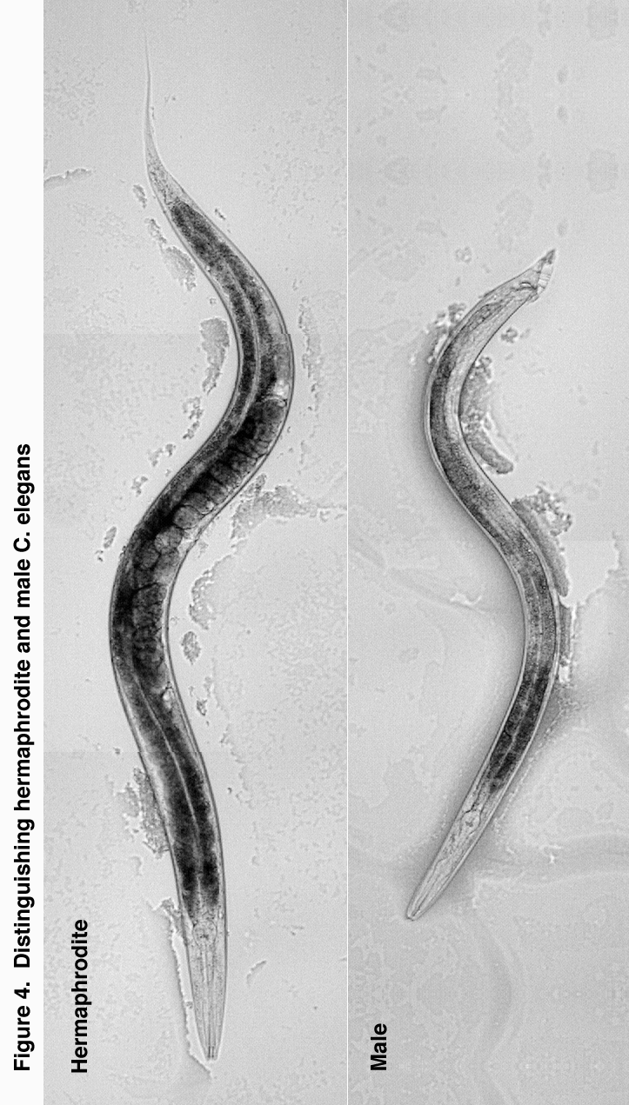

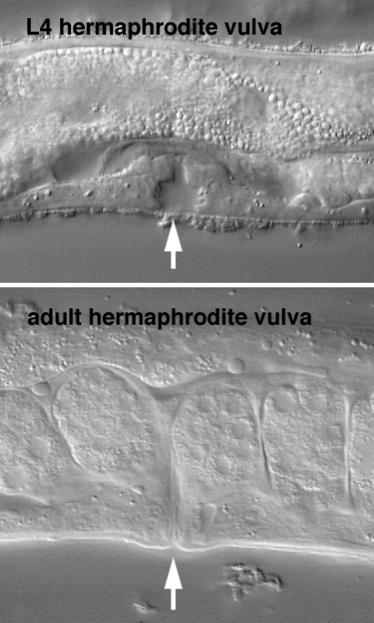

Fig. 5. L4 versus adult hermaphrodites, arrow indicates the vulva.

3. Mating

Distinguishing males and hermaphrodites.

Hermaphrodites can be identified based on the presence of eggs in the uterus, a vulva on the ventral side roughly in the middle of the body, and a long whip on the tail (Fig. 4). Males can be identified because their tail is fan-shaped, they lack a vulva, and they are slightly smaller, thinner, and move faster than hermaphrodites. In addition, in the male the gonad displaces the dark gut on the ventral side and creates a white stripe from the midbody to the tail.

Animals can be mated as L4s or young adults. You must maintain a mating plate of N2 wild types as a source for males in crosses. To generate a wild-type mating plate pick 4 young adult hermaphrodites and ~8 males to a fresh plate. Avoid the large adults as they are probably from the generation before and are now sterile. Mark the plate "N2 ", which indicates that the strain is N2 (our wild-type reference strain) and that it is a mating plate. In 3 days, you will have plenty of males to use in your crosses.

Setting up a cross

Use L4s hermaphrodites for crosses between two strains; this ensures that most progeny are cross-progeny rather than self-progeny. Pick three to four L4 hermaphrodites onto a fresh plate. Crossing L4 hermaphrodites to young adult males will insure that the hermaphrodites will be mated as soon as they molt and that will minimize self progeny.

You need to be confirm that there are no hermaphrodite larvae among your males used in the cross; therefore use a transfer plate. Pick ~8-10 males to a fresh plate and place them away from the bacterial lawn. After they have crawled onto the bacterial lawn, move them again to the plate with the hermaphrodites.

**Mating plates**. Mating plates have a small one centimeter spot of bacteria in the middle. Wild-type males have no difficulty finding and mating to hermaphrodites on non-­mating plates with a large spot of bacteria but if you are setting up a cross with uncoordinated males, confining the hermaphrodites to a small region of the plate by using a small lawn will certainly give the boys a leg up.

**Virgin hermaphrodites**. If the hermaphrodites are the desired progeny resulting from a cross, then pick L4 hermaphrodites rather than young adults. Because the cross will have generated both hermaphrodite and male cross-progeny, you need to ensure that the hermaphrodites are virgins, and have not mated with their siblings. Because the L4 cuticle covers the vulva, by picking L4 hermaphrodites you can be certain that the hermaphrodite has not been previously mated.

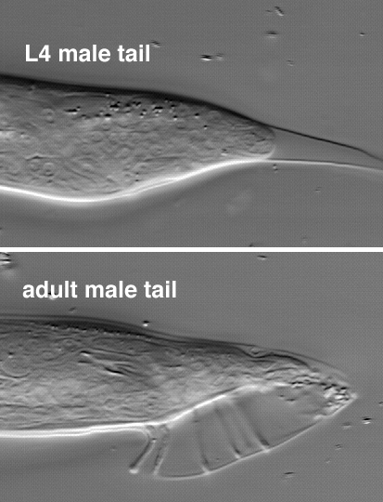

Fig. 6. L4 versus adult males.

Distinguishing L4s from adults.

L4 stage larvae can be distinguished from adults because the larval cuticle covers the developing adult sexual organs. In the L4 hermaphrodite, the developing vulva appears as a clear indentation in the middle of the body (Fig. 5), in the adult the vulva appears as a protrusion in the middle of the body on the ventral side. In the L4 male, the tail is enlarged, the fan appears to be contained in a cellophane bag (the L4 cuticle) and a whip is present (Fig. 6), whereas in the adult male, the fan is unfolded and there is no tail whip.

Obtaining males

Males are used to introduce new mutations into the genetic background of a strain.

1. Wild-type mating plate. Males are usually obtained by maintaining a mating plate of the wild type (N2 is the standard wild-type strain).

To move mutations between strains, wild-type males are mated to a mutant strain. The resulting male progeny will be heterozygous for the mutation. These males can then be mated to a second mutant strain to introduce the first mutation into the progeny (Fig. 7).



2. Mutant mating plate. Alternatively, if homozygous mutant males will mate it is sometimes convenient and faster to maintain a homozygous mutant mating strain (Fig. 8). Mutant males can be generated from a homozygous strain of hermaphrodites by heat shocking the mutant animals. Heat shock during meiosis results in higher levels of X chromosome nondisjunction and hence a higher level of spontaneous males (males have one X chromosome instead of 2 Xs as in hermaphrodites). To obtain males, pick about eight L4 hermaphrodites each, onto 4 -5 plates. Place the plates at 30° for 5 hours. Longer heat shocks will result in sterility. Pick F1 males from the heat-shocked plates and mate to siblings to start a mating population.

Distinguishing cross-progeny from self-progeny.

Crossing males into hermaphrodites is not always 100% effective. The hermaphrodite's own sperm can fertilize her eggs. In theory, the progeny from a crossed hermaphrodite will be a mixture of self-progeny and cross-progeny. To distinguish cross-progeny from self-progeny an irrelevant mutation is often maintained in the background of the hermaphrodite. For example, when one is studying an uncoordinated mutation (Unc phenotype), a mutation causing a dumpy body morphology (Dpy phenotype) is often included (Fig 9).

In practice, male sperm outcompete hermaphrodite sperm, so if adult males are present when an L4 hermaphrodite molts, almost all progeny will be cross-progeny.

4. Cleaning worm strains

There are almost always some contaminants on a plate with worms on it. Therefore, it is good practice to always place animals off the food when moving strains to a fresh plate. There are four kinds of contaminants on worm plates:

1. **Fungi**: Transfer the worms to a fresh plate every 30 minutes for two hours. The worms will clear the fungal spores from their gut and from their cuticle. It is best to leave freshly poured plates out for a couple of days to make sure no fungal colonies grow before adding worms.

To minimize fungal spores in the lab, tape plates closed if they have fungal contaminants. Routinely autoclave aluminum boxes to kill fungal spores. If you find a lot of contaminated plates in the box, remove strains and autoclave box. If the plastic plate containers become contaminated with fungus, the box must be treated with dilute bleach before returning it to the collection.

2. **Non-OP50 bacteria** ("slime"). These are typically yellow or brown, flocculent bacteria. Animals can be cleaned by serial transfer or by bleaching. It is very difficult to cure strains of slime by serial transfer but it can be done, particularly if you are in the middle of a cross and cannot afford to kill a lot of worms by alkaline hypochlorite treatment. Transfer a large number of animals off food to a fresh plate. They need to clear the contaminating bacteria from their gut by eating OP50. After 20 minutes, select those animals on food again. Repeat 4 times.

Bleaching strains: It is usually more effective to decontaminate strains in alkaline hypochlorite solution. Mix 2 ml water, 2ml bleach and a pellet of NaOH in a screw cap tube (.5M NaOH, 2.6% NaOCl). Add a drop to the unseeded portion of a fresh plate. Pick ~10 gravid adults into the drop. The adults and most of the bacteria will quickly dissolve; the eggs will survive. Leave the plate right side up overnight; the drop of liquid will be absorbed, and live hatched L1s will crawl onto the bacterial lawn. It is necessary to move the hatched larvae to a new plate the next day; otherwise surviving bacteria will eventually spread over the plate and recontaminate the worms. The alkaline hypochlorite stock solution lasts a couple of weeks.

Some strains are so Unc that the L1s will never crawl onto the seeded portion of the plate and alkaline hypochlorite method will not work. In this case you have to outrun the bacteria using serial transfer directly onto the food. Move the animals to clean bacteria whenever they get away from the contaminated spot. This can be as often as every 20 minutes for an active strain or a couple of times a day for an inactive strain.

I once got a filamentous bacteria that stuck to the cuticle of the worms. It gave them a "squirmy dog" uncoordinated phenotype, that is, the worms would generate a wave form but they were incapable of moving anywhere. I thought I had a way-cool mutant until I became suspicious and mixed a nonUnc strain with the "mutant" and got horizontal transfer of phenotype. No amount of serial transfer would clean the worms - only molting managed to clean them up.

Some labs use antibiotics in their plates. This is generally not advisable, since it is not known what effects the antibiotics have on the worms. Of course you need to seed plates with a bacterial strain that is resistant to the antibiotic. Include 200 ug/ml streptomycin and 10 ug/ml nystatin in molten NGM agar. The nystatin does a good job on yeast contaminants, but is almost completely useless against mold.

3. **Phage**. Bacterial phage contamination appears as a clear spot in a bacterial lawn which is recognizable only in paralyzed strains. In active strains you can see that the bacteria lawn turns clear and the food becomes very goopy. Treat as described above under bacteria. It is very difficult to get rid of phage, and it greatly reduces worm proliferation.

4. **Mites**. Mites will scare the crap out of you when they stumble into view under high power on the dissecting scope. The hairs on your neck become rigid. Mites eat nematodes. They import fungus. They could cross contaminate worm strains by carrying worms between plates. Untended plates will become mite farms, then rodeos, then cities with their own mite newspapers and urban problems.

Remove a few worms to a fresh plate. Bake contaminated plates and boxes in the oven overnight. Wipe down shelves and floors with a bleach solution. Wash your hands vigorously until the skin comes off but nothing will free you from that feeling that there are mites crawling on the tiny hairs that cover your mammalian body.

5. Storage

1. Active strain maintenance. A strain is always started from a cloned animal and frozen to maintain a reference stock. Thereafter the strain must be maintained as a population, otherwise new mutations will become fixed in the population. Maintain strains by picking >10 worms to the unseeded portion of a fresh plate. Worms will crawl away from a contaminant and onto the fresh food. Worms picked from fresh bacteria will be clean of bacterial contaminants.

2. Starved plates. Worms kept at 20°C will eventually starve the plate. Such a plate can be maintained for a week or two in the incubator but will eventually dry out and the worms will die. Worms can be recovered from starved plates by cutting a chunk of agar to a fresh plate. Use a flamed spatula to cut a 1 cm chunk of agar. Flip the chunk onto the agar of a fresh plate; place the chunk at the edge of the plate away from the food. The day after chunking, pick ~20 worms to a fresh plate, since bacterial contamination is invariably introduced on the chunk of agar. If the strain is paralyzed or severely uncoordinated, place the chunk on the food and slide it to the edge.

3. 15° storage. Freshly starved, clean plates can be sealed with parafilm and stored at 15°C for up to six months. Plates must be completely cleared of bacteria; otherwise bacterial growth on an unstarved plate will use up the oxygen in a sealed plate and kill the strain. Bacterial contamination often causes strains to be sick or arrests growth of worms on the short term; fungal contamination will usually kill a strain stored at 15°. Therefore only store clean plates and periodically check 15° stocks for fungal contamination.

4. Shipping. Plates that are mailed must be fully starved. Wrap the plate with parafilm and ship in a padded envelope. A starved population will be composed of L1 arrests or dauer larvae which can tolerate the absence of food. Such animals are resistant to changes in temperature and can be shipped quite safely. If shipping is a rush, an unstarved plate can be shipped by punching a few holes in the parafilm around the edges of the plate.

5. -80° storage. All strains should be maintained in a permanent frozen collection at -80°C or in liquid nitrogen in cryovials.

6. Dried chips - or the miracle of Easter. Although dried agar chips are not a recommended form of storage, everyone resorts to them unintentionally. At some point you will realize you needed a strain from a month ago and you find the box with the correct plates but they are all dried. You can recover such strains by rehydrading the chip. If the agar chip is completely dried, it rarely yields viable worms, but if there is any part still adherent to the plastic you can still recover the worms. Simply add distilled water and let soak for a few hours. Pour the excess water onto seeded agar and let it soak in. Cut up the rehydrated chip and flip the chunks onto fresh seeded plates. In a couple of days a few worms might crawl out.